Deployment details using openshift:

As part of deployment process we use redhat openshift paas container.we deployed all the microservice to this container through jenkin pipeline job.Openshift has the capability of routing i.e nothing but does the job of apigateway and also have loadbalancing capability.

Once the service is deployed into openshift it treated as one pod. Pod is nothing but the instance and based on the incoming request or load the pods are autoscaled to 2 or 3 i.e 2 instance or 3 instance are created.openshift handle the loadbalancing while routing the request.

Apart from this to subscribe the each endpoint of service we use ibm api marketplace. Here all endpoint of microservice are subscribed to marketplace. The benefit of using market place is to maintain the abstraction from direct acces openshift endpoint and also it imposed security using ibm secretkey,secrevalue for validate the jwt token.it facilitate to hide some endpoint from outside user i.e user can acces only those endpoint which are subscribe to marketplae.

Exampe: suppose I have a service as payment-holiday and it contains 5 endpoint as

3Get request ,1 post request , 1 delete request. If I don’t subscribe the delete endpoint in marketplace then no one can access the delete endpoint.

The microservice communication also done through the marketplace endpoint only.

For example: suppose service1 is calling to service2. service1 invoke the endpoint of service2 from the endpoint publish in marketplace instead of directly calling the openshift url.

All service communication done through marketplace api endpoint only. Marketplace api act as a abstraction over the openshift.

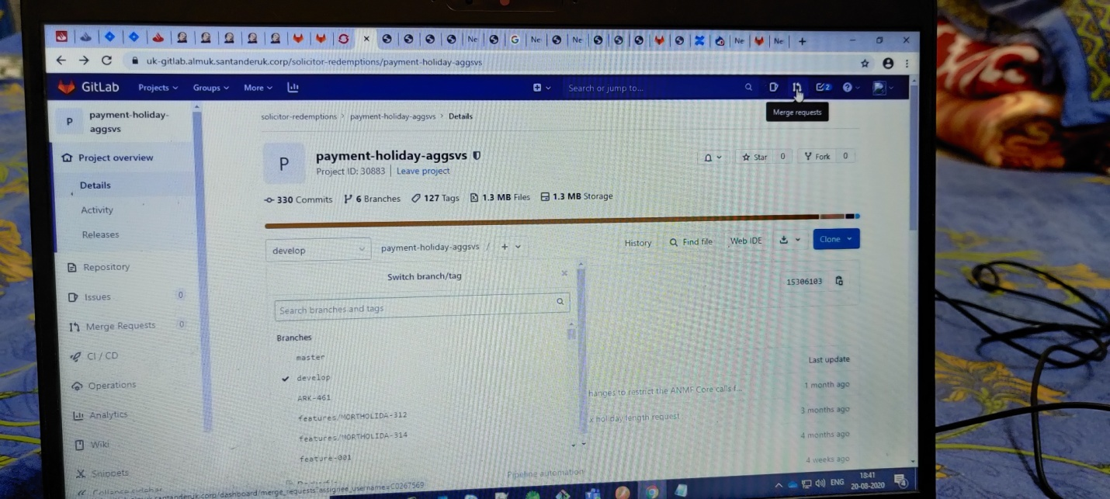

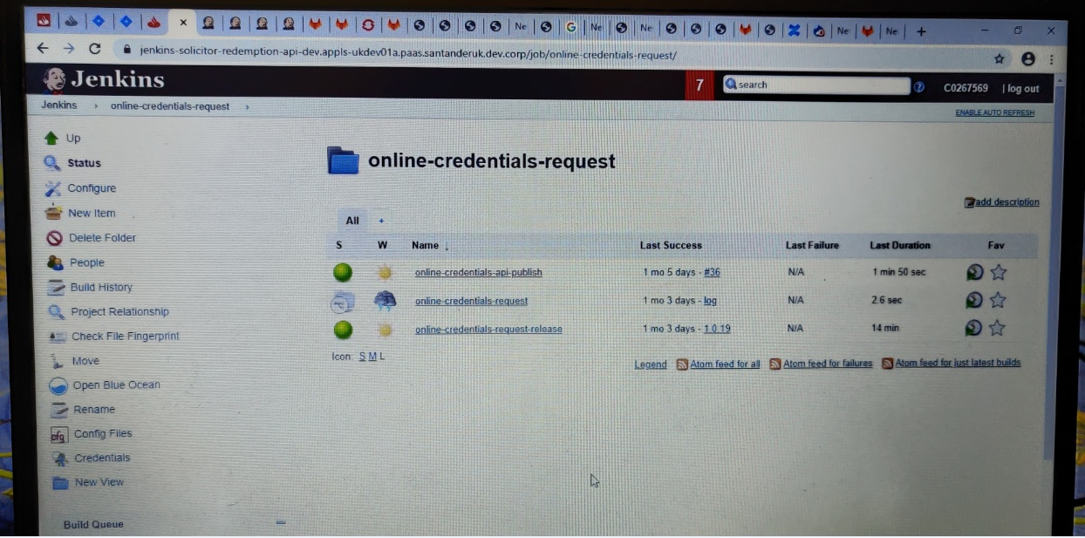

Ibm api marketpace used to subscribe all the microservicec endpoint to internal or external marketplace.

It helps to restrct the specific endpoint which we don’t want to expose.

It helps to provide security by imposing ibmsecretkey,ibmsecretvalue to each endpoint. All endpoint has to validate with jwt token creation by using the secretkey and secret value.

User always request to marketplace endpoint and marketplace call to openshift.

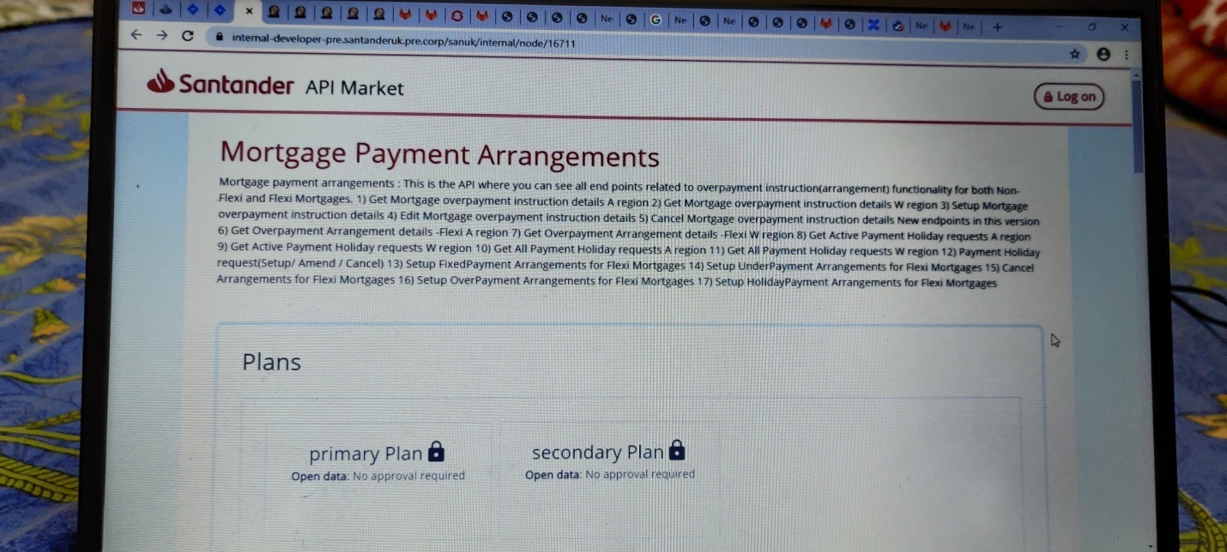

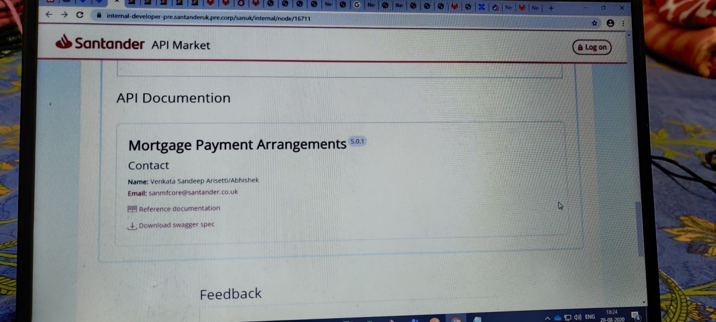

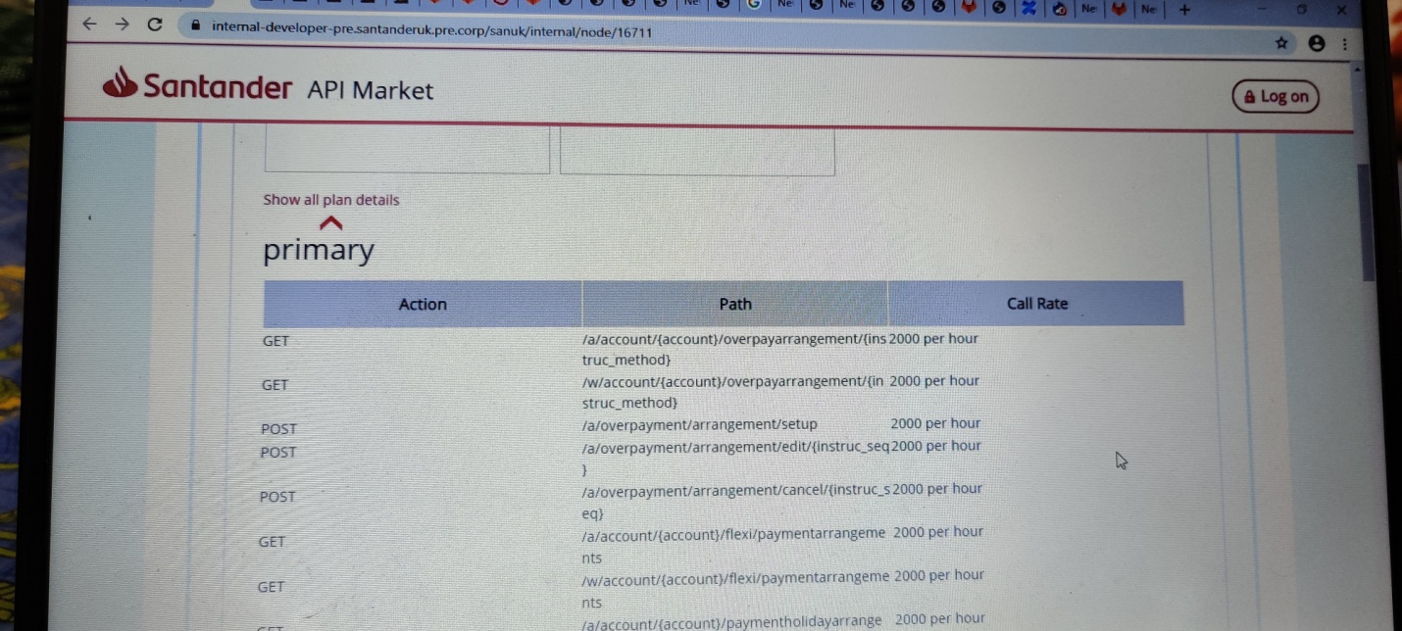

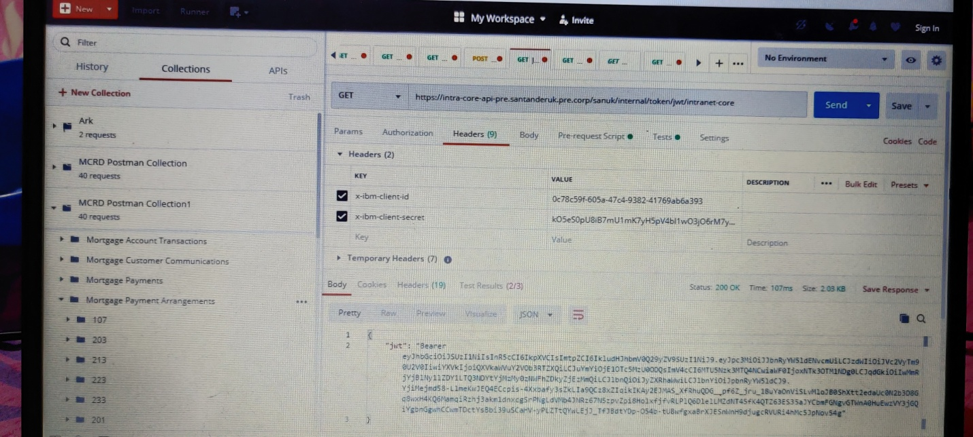

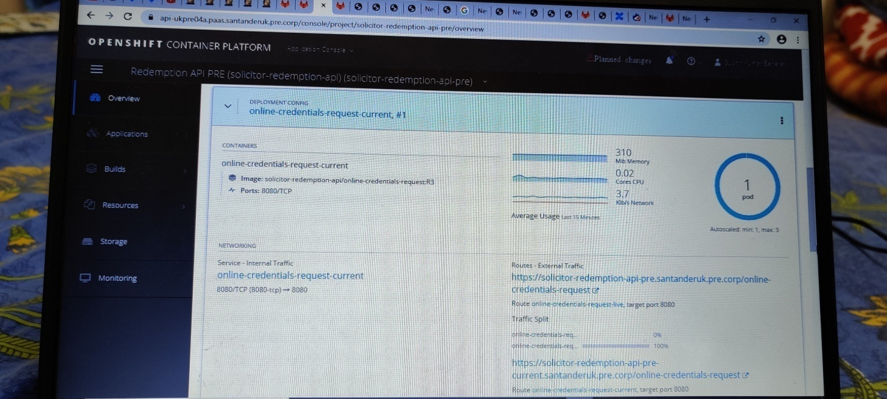

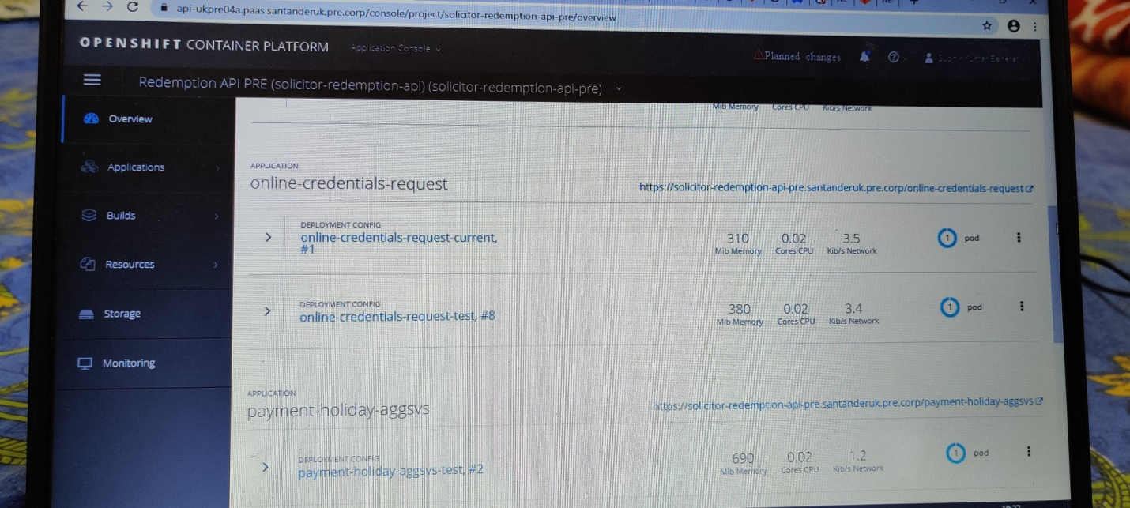

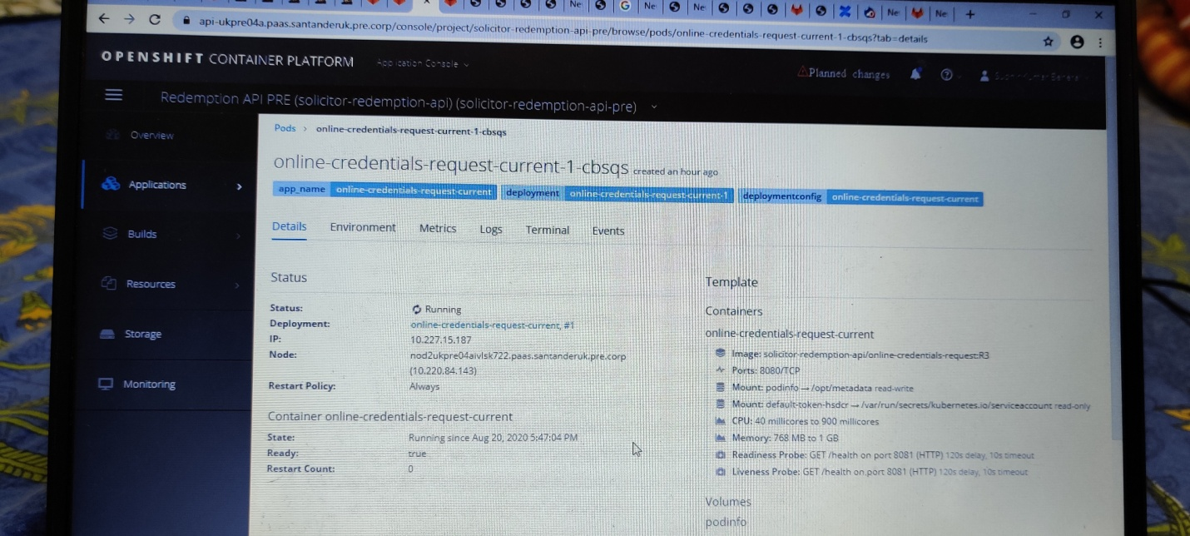

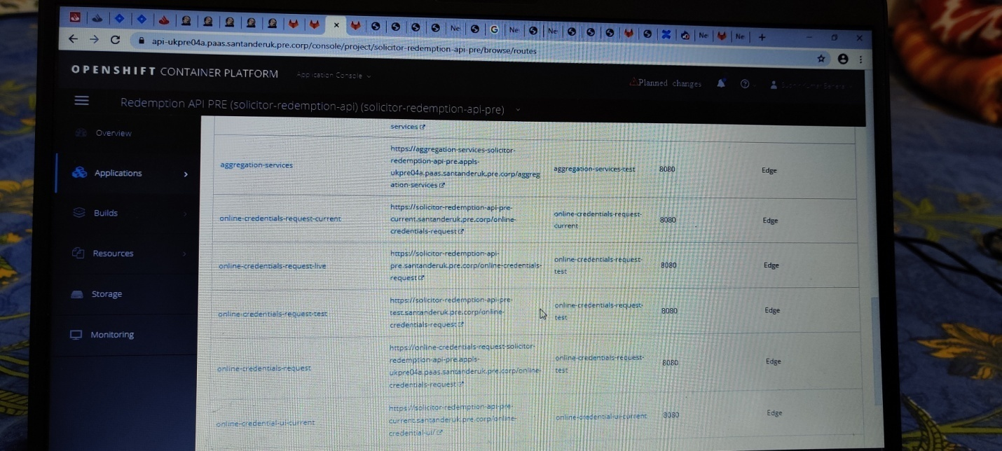

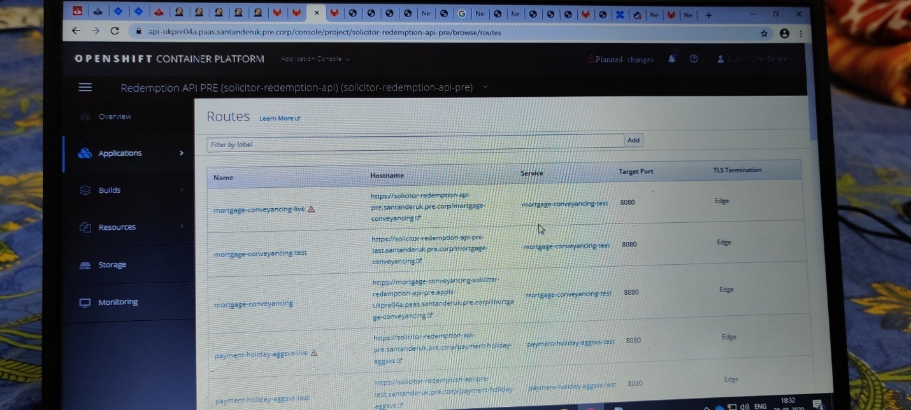

Openshift is a paas environment where all microservice get deployed.

Each service is treat as a pod and each pod can have multiple instance for load balancer.

We use two openshift paas environment so if for any reason the pod is crashed or openshift is down then another openshift paas environment can handle the situation.

In the openshift there is a monitoring tab where we can check all the microservice health status details.

API gateway job is handle by openshift itself and when request comes from marketplace it does the route of request to particular service.